PUBLIC Education

Senior Center:_______________________ Month:_____________
Public Education-3 required per month
*Public Education is providing non-nutrition related knowledge, experiences or skills to participants. This service is to increase awareness on various topics other than nutrition. 1 contact = 1 unit in AIMS. | Units  Monthly  Total | Clients  Monthly  Total
Example 1: Fire Department speaks @ Center about fire safety in the home to your 17 congregates (17 units = 17 clients).
Example 2: Provided flyer to both your C1 & C2 participants about Medicare Fraud (25 units = 25 clients)
Example 3: Home Health Nurse speaks @ Center about their services to 15 congregates (15 units = 15 clients)

Speaker/Handout: | Topic: | Date: | #of clients

Nutrition Education 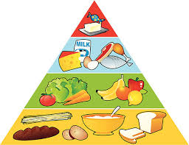
Senior Center:_______________________ Month:_____________
Nutrition Education  C1 required to provide 4x per Month  C2 required to provide 1x per Quarter | Units C1  Monthly Total | ClientsC1  Monthly Total
Example 1: Center Manager reads one of the ADSS provided Nutrition Ed topics to 25 clients = 25 units. If you do this 4x during a month to 25 clients it is 100 clients = 100 units
Example 2: ADSS Nutrition Ed is given to 15 homebound clients; 15 clients = 15 units
Example 3: Florence Nightingale from ABC Home Health speaks @ Center about Food Safety & Dining Out to 25 clients = 25 units
 | Units C2 Monthly Total | Clients C2  Monthly Total

Congregate
Topic: | Date: | # of clients
Homebound-provided in _______________this Quarter | Date:

