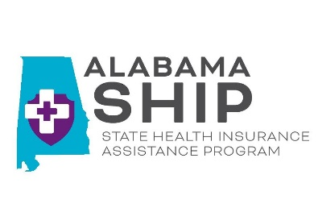
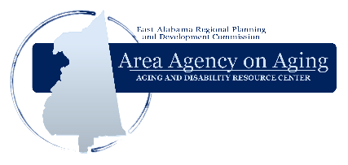
Get Your FREE
Medicare Checkup

The State Health Insurance Assistance Program (SHIP)
will be available to help you:

  - Understand your Medicare benefits.
  - Determine which Part D plan best fits your needs.
  - Enroll in a plan of your choice.
  - File a Medicare claim or appeal.
  - Answer questions about your health insurance.

Join us for the 2023 Open Enrollment Season to review the 2024
First come, first serve basis.
No appointment needed.

Bring your Medicare Card and a list of your current medications with strength & dosage.
Medicare Part D and Medicare Advantage plans
When: October 15th- December 7th
Where: Phone, virtual, office

The following appointment types are available
for Open Enrollment:

On-site Appointment and Phone Appointment

Calhoun, Chambers, Cherokee, Clay, Cleburne, Coosa, Randolph,
Talladega, Tallapoosa Counties
1130 Quintard Ave.
Anniston, AL 36202
1-800-AGELINE (1-800-243-5463)

Office appointment requirements: Masks are not required but optional. Clients showing signs of illness will not be permitted on premises and will be asked to reschedule appointment. Clients must have Medicare Card and list of prescription drugs available at time of appointment.

Phone appointment requirements: A SHIP Counselor will call you at the time of your scheduled appointment. Clients must have Medicare Card and list of prescription drugs available at time of appointment.

